**PaGent**

*(Redirecting Focus)*

Product Requirement

**Business Need**

Objective: This website would make shopping for male wears easy and within the reach of all class in very simple steps.

**Product Goals**

The goal is to ensure both merchants and customers satisfaction at all point. Making sure the busy merchant has a market for all class and types of person without a direct interaction of persons. And for a busy customer to be able to dress properly.

**Features**

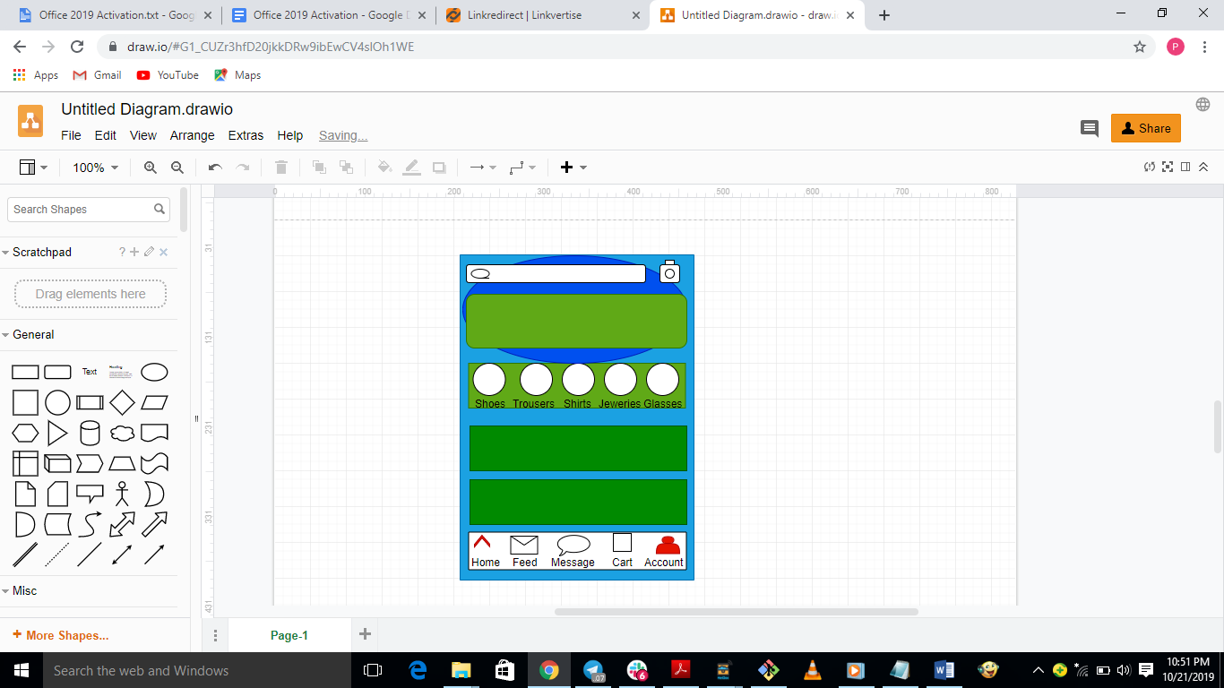

|  |  |  |
| --- | --- | --- |
|  | Home | this icon is to enable customers be able to access the main page from any part of the app |
|  | Feed | * This icon is to enable customers be able to visit different merchant stores within the app and same time shop from them. * And also, be able to make communication with the merchant by sending messages with the store to the merchant. |
|  | Messages | * This icon would enable an easy communication between the merchant and the customers all on the app. Without a direct sharing of email or numbers. For privacy purpose. * All communication started within the stores can also be seen on the message icon and also continue the relationship with merchant outside their store. |
|  | Cart | * This icon would enable the customer to be able to keep selected items for future payment. * It would also serve the customer to be able to make easy comparison of items from different stores. |
|  | Account | * This would take the customers to a login page which would enable new users to register and also be able to get password retrieval when needed. * This icon enables the customers to be able to open an account with PAGent and shop with ease. * This opens a unique page with login details for the customer alone. |
|  | Search | * This icon would enable the customer to be able to sort out items based on preferred store and design. * Multiple options would be available when using the search icon. |